Year 6 going into Year 7 English
Summer Work Booklet

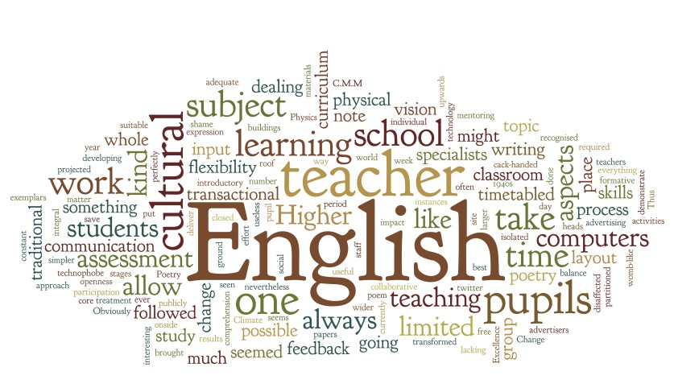

SECTION 1 - Independent Reading and Book Review

Select ANY of the suggested novels below and read it independently. You should read about 5 chapters every week.
- I am Malala by Malala Yousafzai
- Little House on the Prairie by Laura Ingalls Wilder
- Call of the Wild by Jack London
- Wonder by R.J.Palacio

TASK 1: Book Review
Complete this book review in detail:
BOOK TITLE: _______________________________________________________________________________
AUTHOR: __________________________________________________________________________________
GENRE: ___________________________________________________________________________________
SUMMARY OF CONTENT: _____________________________________________________________________
__________________________________________________________________________________________________________________________________________________________________________________________________________________________________________________________________________________________________________________________________________________________________________________________________________________________________________________________________________________________________________________________________________________________________________________________________________________________________________________________________________________________________________________________________________________________________________________________________________________________________________________________________________________________________________________________________________________________________________________________________________________________________________________________________________________________________________________________________________________________________________________________________________________Give an example of something that you liked in the novel.
________________________________________________________________________________________________________________________________________________________________________________________________________________________________________________________________________________________________________________________________________________________________________
Give an example of something that you would change in the novel. Explain your choice.
________________________________________________________________________________________________________________________________________________________________________________________________________________________________________________________________________________________________________________________________________________________________________
Recommend this book to a friend and explain why they should read it.
______________________________________________________________________________________________________________________________________________________________________________________________________________________________________________________________________________

SECTION 2 - Reading Comprehension Passage

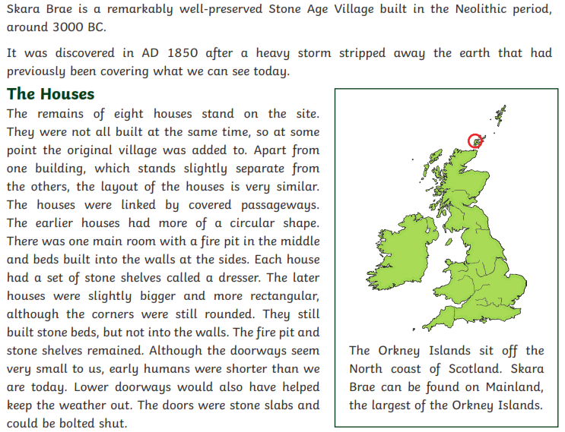

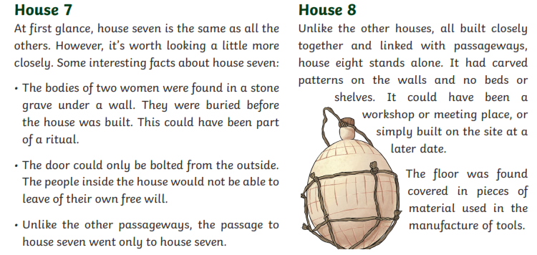

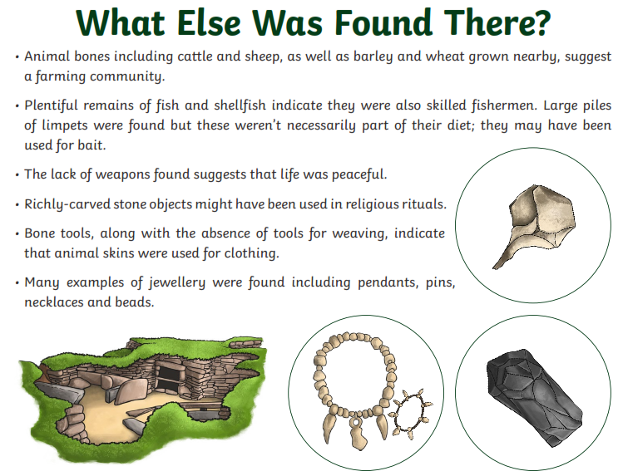

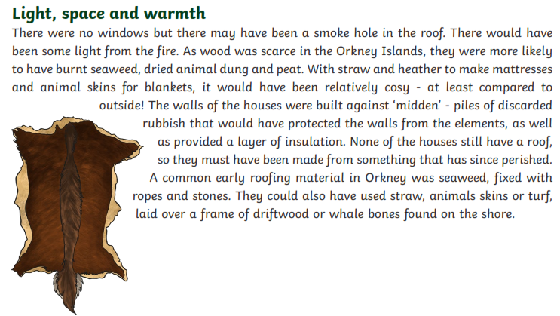

TASK 1: OPEN - ENDED QUESTIONS
Answer the questions below using COMPLETE ANSWERS:

1. What is Skara Brae?
______________________________________________________________________________________________________________________________________________________________________________________________________________________________________________________________________________
2. According to the text, how are the earlier houses different from the later houses ?
________________________________________________________________________________________________________________________________________________________________________________________________________________________________________________________________________________________________________________________________________________________________________
3. What was an advantage of lower doorways?
______________________________________________________________________________________________________________________________________________________________________________________________________________________________________________________________________________
4. What could you find in the centre of each house?
______________________________________________________________________________________________________________________________________________________________________________________________________________________________________________________________________________

5. What do you think House 8 was used for? Why?
____________________________________________________________________________________________________________________________________________________________________________________
6. What piece of evidence suggests that the people in this community lived a peaceful life?
______________________________________________________________________________________________________________________________________________________________________________________________________________________________________________________________________________
7. Give some examples of jewellery found here.
____________________________________________________________________________________________________________________________________________________________________________________

TASK 2: MULTIPLE - CHOICE QUESTIONS
1. When was the Skara Brae Stone Age Village built?
- 1850 AD c) 2019
- around 3000 BC d) none of the above
2. How many houses formed the village?
- four c) five
- seven d) eight
3. The earlier houses were...
- rectangular with built stone beds in the walls
- circular with beds into the walls at the sides
- rectangular with no fire pit in the middle
- circular with shelves made of wood
4. According to the passage, what was most likely House 7?
a) school
b) hospital
c) jail
d) church
5. According to the evidence found in this place, this community was most likely...
- a warrior community
- a religious community
- a scholars community
- a farming community
6. How did they heat their houses?
- using wood
- using electricity
- using animal skin
- using seaweed and dried animal dung

Task 3: VOCABULARY
Identify 10 new vocabulary words in the passage and look up their meaning in the dictionary.

NEW VOCABULARY WORD | DEFINITION
1.

2.

3.

4.

5.

6.

7.

8.

9.

10.

TASK 4: SENTENCE BUILDING
Create 5 original sentences with 5 words of your choice from the new vocabulary found.
Write them on the line.

a) ___________________________________________________________________________________

___________________________________________________________________________________

b) ___________________________________________________________________________________

___________________________________________________________________________________

c) ___________________________________________________________________________________

___________________________________________________________________________________

d) ___________________________________________________________________________________

___________________________________________________________________________________

e) ___________________________________________________________________________________

__________________________________________________________________________________

SECTION 2 - Narrative Writing

Choose ONE of the prompts below and create an original story. Include characters, dialogue, great vocabulary and an interesting plot. Give your story a catchy title.

a) Write a story that begins with the sentence: "That was something I did not expect to happen."

b) Write a story that ends with: "And this was the end of a great adventure."

c) Tell the story of two friends who get lost while camping in the forest.

d) Tell the story of a boy who discovers one day that he can fly.

_________________________________________

________________________________________________________________________________________________________________________________________________________________________________________________________________________________________________________________________________________________________________________________________________________________________
________________________________________________________________________________________________________________________________________________________________________________________________________________________________________________________________________________________________________________________________________________________________________
________________________________________________________________________________________________________________________________________________________________________________________________________________________________________________________________________________________________________________________________________________________________________
________________________________________________________________________________________________________________________________________________________________________________________________________________________________________________________________________________________________________________________________________________________________________
________________________________________________________________________________________________________________________________________________________________________________________________________________________________________________________________________________________________________________________________________________________________________
____________________________________________________________________________________________________________________________________________________________________________________________________________________________________________________________________________________________________________________________________________________________________________________________________________________________________________________________________________________________________________________________________________________________
________________________________________________________________________________________________________________________________________________________________________________________________________________________________________________________________________________________________________________________________________________________________________
________________________________________________________________________________________________________________________________________________________________________________________________________________________________________________________________________________________________________________________________________________________________________
________________________________________________________________________________________________________________________________________________________________________________________________________________________________________________________________________________________________________________________________________________________________________
________________________________________________________________________________________________________________________________________________________________________________________________________________________________________________________________________________________________________________________________________________________________________
______________________________________________________________________________________________________________________________________________________________________________________________________________________________________________________________________________________________________________________________________________________________________________________________________________________________________________________________________________________________________________________________________________________________________________________________________________________________________________________

