Year 10 English
Summer Work Booklet

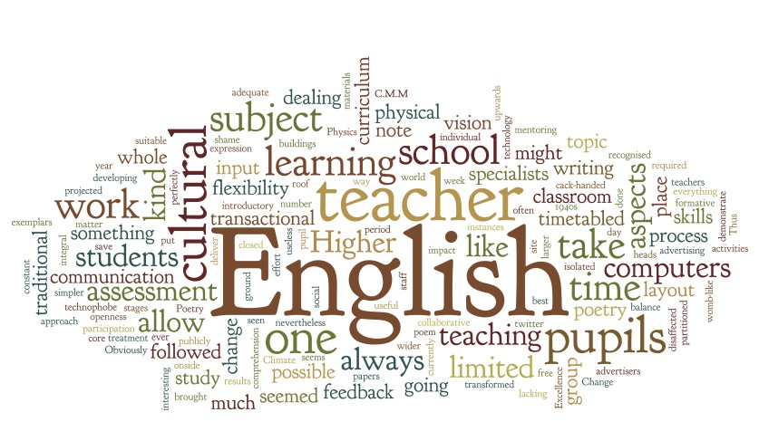

SECTION 1 - Independent Reading and Book Review

Select ANY of the suggested novels below and read independently. You should read about 5 chapters every week.
- Little Women by Louisa May Alcott
- Moby Dick by Herman Melville
- Oliver Twist by Charles Dickens
- The Maze Runner by James Dashner
- The Fault in Our Stars by John Green
TASK 1: Book Review
Complete this book review in detail:
BOOK TITLE: _______________________________________________________________________________
AUTHOR: __________________________________________________________________________________
GENRE: ___________________________________________________________________________________
SUMMARY OF CONTENT: _____________________________________________________________________
______________________________________________________________________________________________________________________________________________________________________________________________________________________________________________________________________________________________________________________________________________________________________________________________________________________________________________________________________________________________________________________________________________________________________________________________________________________________________________________________________________________________________________________________________________________________________________________________________________________________________________________________________________________________________________________________________________________________________________________________________________________________________________________________________________________________________________________________________________________________________________________________________________________________________________________________________________________________________________________________________________________________________________________________________

______________________________________________________________________________________________________________________________________________________________________________________________________________________________________________________________________________
______________________________________________________________________________________________________________________________________________________________________________________________________________________________________________________________________________
______________________________________________________________________________________________________________________________________________________________________________________________________________________________________________________________________________
Give an example of something that you liked in the novel and explain why you liked it.
__________________________________________________________________________________________________________________________________________________________________________________________________________________________________________________________________________________________________________________________________________________________________________________________________________________________________________________________
_____________________________________________________________________________________________________________________________________________________________________________
Give an example of something that you would change in the novel. Explain your choice.
______________________________________________________________________________________________________________________________________________________________________________________________________________________________________________________________________________________________________________________________________________________________________________________________________________________________________________________________________________________________________________________________________________________
Recommend this book to a friend and explain why they should read it.
_________________________________________________________________________________________________________________________________________________________________________________________________________________________________________________________________________________________________________________________________________________________________________________________________________________________________________________________________________________________________________________________________________________________________________________________________________________________________________________
SECTION 2 - Reading Comprehension

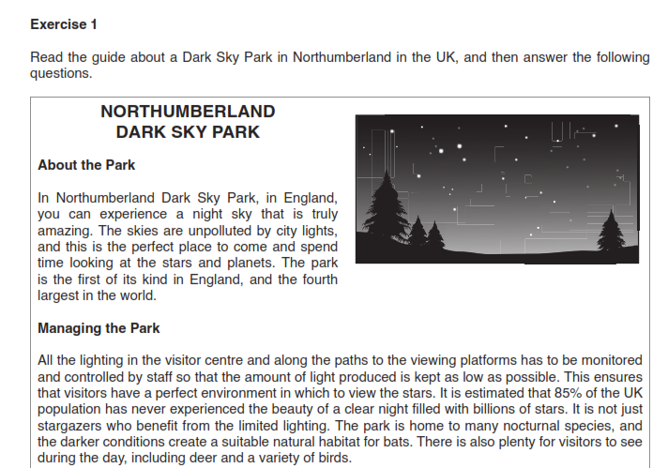

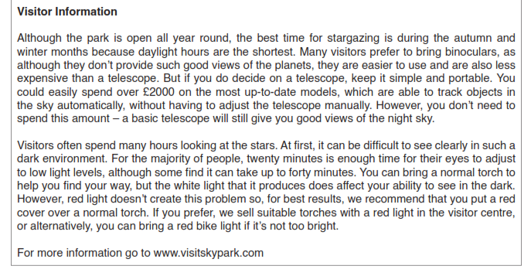
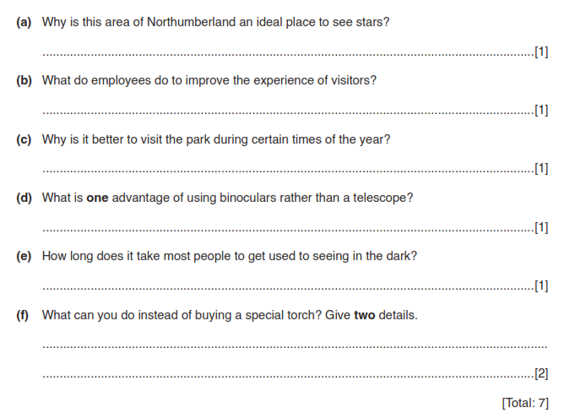

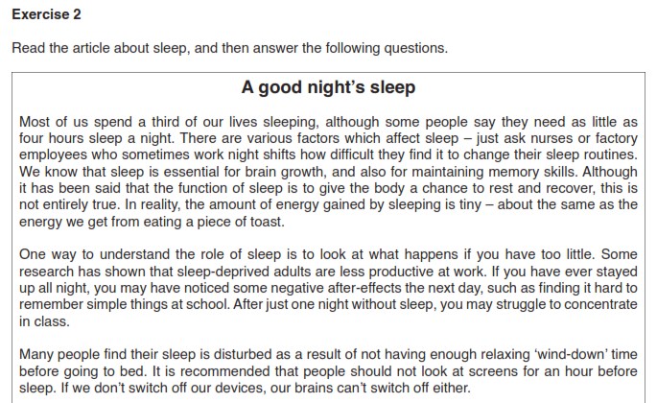

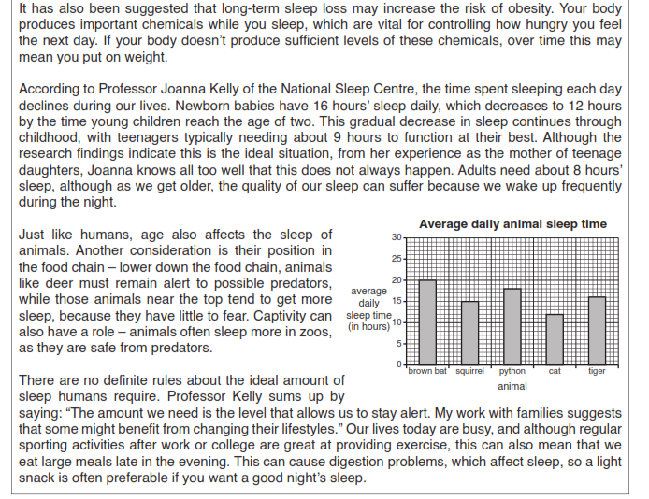
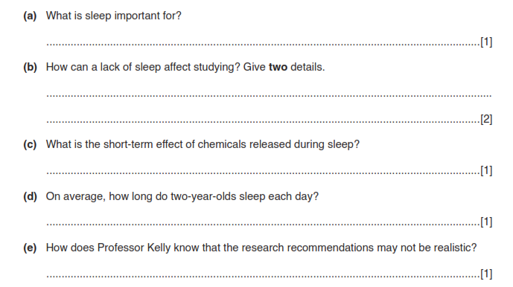
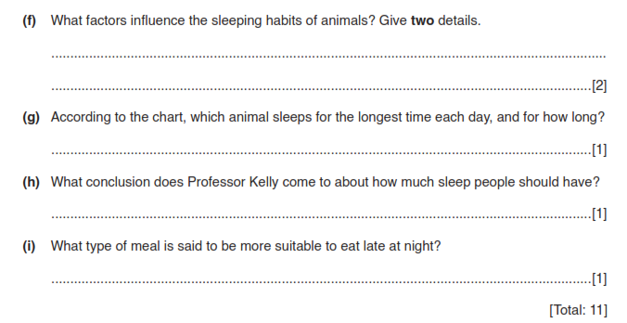

SECTION 3 - Writing
Task 1: Letter Writing

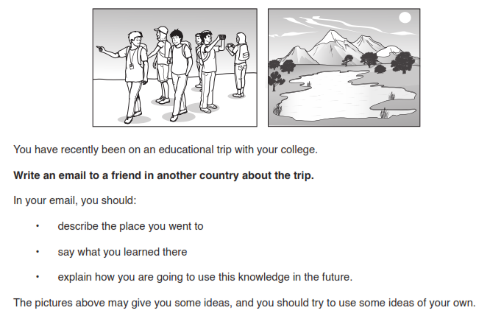

________________________________________________________________________________________________________________________________________________________________________________________________________________________________________________________________________________________________________________________________________________________________________
________________________________________________________________________________________________________________________________________________________________________________________________________________________________________________________________________________________________________________________________________________________________________
________________________________________________________________________________________________________________________________________________________________________________________________________________________________________________________________________________________________________________________________________________________________________
________________________________________________________________________________________________________________________________________________________________________________________________________________________________________________________________________________________________________________________________________________________________________
________________________________________________________________________________________________________________________________________________________________________________________________________________________________________________________________________________________________________________________________________________________________________
____________________________________________________________________________________________________________________________________________________________________________________________________________________________________________________________________________________________________________________________________________________________________________________________________________________________________________________________________________________________________________________________________________________________
________________________________________________________________________________________________________________________________________________________________________________________________________________________________________________________________________________________________________________________________________________________________________
Task 2: Summary
Summarise the text below using your own words as much as possible.
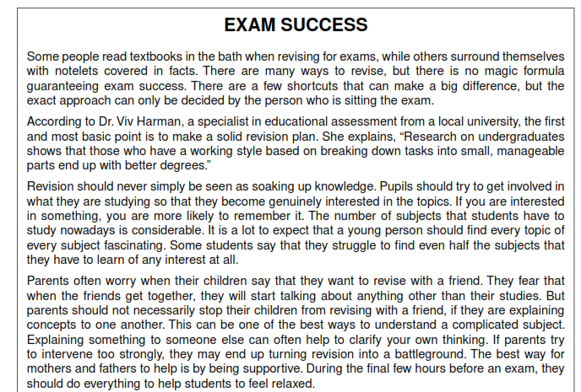
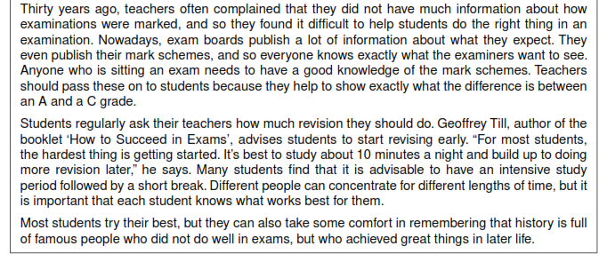
________________________________________________________________________________________________________________________________________________________________________________________________________________________________________________________________________________________________________________________________________________________________________
________________________________________________________________________________________________________________________________________________________________________________________________________________________________________________________________________________________________________________________________________________________________________
________________________________________________________________________________________________________________________________________________________________________________________________________________________________________________________________________________________________________________________________________________________________________
________________________________________________________________________________________________________________________________________________________________________________________________________________________________________________________________________________________________________________________________________________________________________
______________________________________________________________________________________________________________________________________________________________________________________________________________________________________________________________________________________________________________________________________________________________________________________________________________________________________________________________________________________________________________________________________________________________________________________________________________________________________________________
TASK 3: Article Writing







