KS4 CompuWHU 6FLHQFH
KS4 Computer Science

Year 10 computer Science Summer Holiday Revision

KS4 Baseline Test

Resources

1 Computer models are used extensively in computing. (a) What is a Computer Model? (Tick one answer)
(A) A computer model is a hardware component found on the motherboard [ ]

(B) A computer model is a representation of a real-life system or situation [ ] (C) A computer model is an operating system [ ]
(D) A computer model is a type of network [ ]

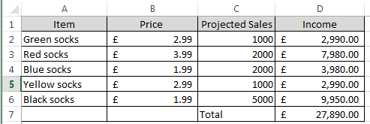
(b) The spreadsheet below is used by a company that sells socks to project how many socks they will sell of each colour in the coming year.

(i) Which number is typed in cell C5? ……………………………

(ii) What is the text typed in cell A2? …………………………….

(iii) The income is calculated using a formula. What is the formula that has been used in cell

D2? ………………………………..

(iv) The total income is calculated using a formula. What is the formula that has been used in cell D7? ………………………………..

(v) The director of the company has found out that red is going to be a fashionable colour in the coming year and she has decided that she wants to change the projected sale of red socks from 2000 to 4000. When she makes this change to cell C3, the figures in which two cells will change automatically? …………………………… ……………………………….

(c) An airline uses a flight simulator to train their pilots.

(i) How is learning to fly in a flight simulator similar to learning to fly in a real plane?

……………………………………………………………………………………………………………………………………

……………………………………………………………………………………………………………………………………

(ii) How is learning to fly in a flight simulator different from learning to fly in a real plane?

……………………………………………………………………………………………………………………………………

……………………………………………………………………………………………………………………………………

……………………………………………………………………………………………………………………………………

(iii) Why do airlines use a flight simulator to train their pilots rather than training them in a real plane?

……………………………………………………………………………………………………………………………………

……………………………………………………………………………………………………………………………………

……………………………………………………………………………………………………………………………………

2 (a) Match each word to the correct definition.

1

Algorithm
A This involves filtering out (or ignoring) the characteristics that we don't need in order to concentrate on those that we do.

2

Decompose
B It involves breaking down a complex problem or system into smaller parts that are more manageable and easier to understand.

3
Pattern Recognition
C This is a list of rules to follow in order to solve a problem. The steps need to be in the right order.

4

Abstraction
D Once we have broken down a complex problem, it helps to examine the small problems for similarities. These
similarities can help us to solve
complex problems more efficiently.

(b) Aisha has installed a new external lamp outside of her house (Figure 1). She has produced an algorithm that asks whether the light sensor, which is built into the lamp, detects daylight. If the answer is YES then the external lamp will turn off. However, if the answer is NO then the external lamp will turn on.

Complete the flow chart below to show her algorithm.

Figure 1

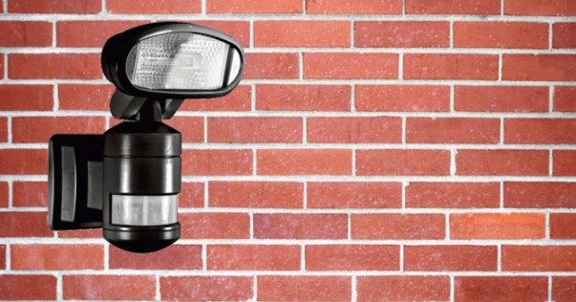

Start

NO B A

YES

C

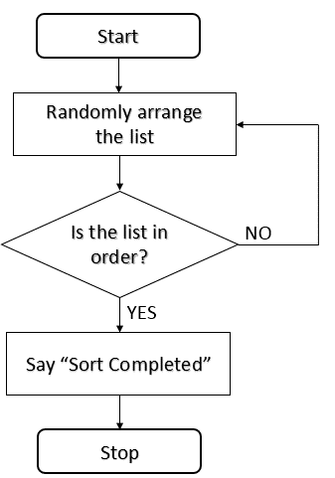
(c) Here is another algorithm displayed as a flow chart.

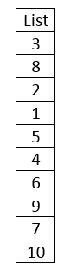

Figure 2

(i) What is the purpose of the algorithm shown in figure 2?

…………………………………………………………………………………………………………………………………………

………………………………………………………………………………………………………………………………………..

…………………………………………………………………………………………………………………………………………

(ii) Why do computer programmers consider this algorithm to be an inefficient solution?

…………………………………………………………………………………………………………………………………………

………………………………………………………………………………………………………………………………………..

…………………………………………………………………………………………………………………………………………

3 You have been given the code below to draw shapes using a computer program called
Logo. When you use Logo FD 100 = Forward 100 steps; RT 90 = Right Turn 90 degrees.

(a) (i) Put the code in the correct order so that a square can be drawn.

Write the code in the correct order here:

FD 100
FD 100
FD 100
FD 100
RT 90
RT 90
RT 90
RT 90

(ii) Put the code in the correct order so that a triangle can be drawn.

Write the code in the correct order here:

RT 120
FD 100
FD 100
FD 100
RT 120
RT 120

(b) You have been given the code below to draw shapes using a computer program called
Scratch.

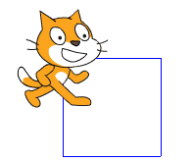
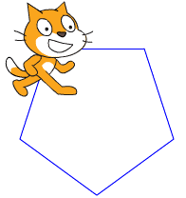
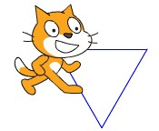

Complete the Scratch code below (fill in the white circles with a number) so that the cat draws each shape. Shape A has been done for you.

Shape A is a Triangle Shape B is a Pentagon Shape C is a Square

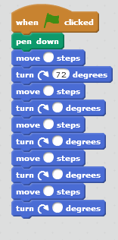
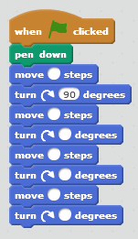
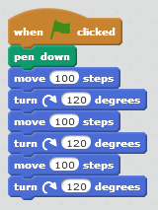

(c) (i) What is meant by iteration?

……………………………………………………………………………………………………………………………………

……………………………………………………………………………………………………………………………………

……………………………………………………………………………………………………………………………………

(ii) How could iteration be used to reduce the length of this program?

……………………………………………………………………………………………………………………………………

……………………………………………………………………………………………………………………………………

……………………………………………………………………………………………………………………………………

4 (a) Below is an algorithm that requires the answer to two questions:

1) Is the green flag flying?
2) Is it sunny?
The dog has decided that if it is sunny and the green flag is flying (The green flag
means that the water is safe to swim in), then it’s time to go for a splash in the sea.

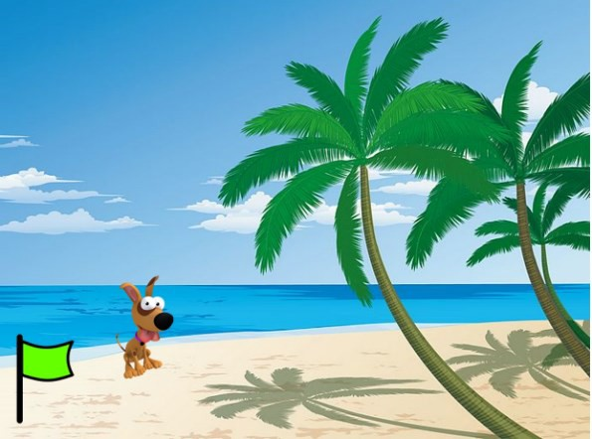

Here is the algorithm:

ASK “Is the green flag flying?”

STORE answer1

ASK “Is it sunny?”

STORE answer2

IF answer1=”YES” AND answer2=”YES” MOVE FORWARD 100 #enters the sea ELSE
MOVE FORWARD 0 #doesn’t enter the sea

(a) Complete the chart to show whether each of the statements in the table is TRUE
or FALSE

Green flag up? | Boolean  Operator | Sunny? | Run into Water?  True or False?
YES | AND | YES
YES | AND | NO
NO | AND | YES
NO | AND | NO

(b) Now the AND Boolean Operator in the program code has been replaced by an OR
Boolean Operator. Here is the algorithm: ASK “Is the green flag flying?” STORE answer1
ASK “Is it sunny?”

STORE answer2

IF answer1=”YES” OR answer2=”YES” MOVE FORWARD 100 #enters the sea ELSE
MOVE FORWARD 0 #doesn’t enter the sea

Complete the chart to show whether each of the statements in the table is TRUE or FALSE.

Green flag up? | Boolean  Operator | Sunny? | Run into Water?  True or False?
YES | OR | YES

YES | OR | NO
NO | OR | YES
NO | OR | NO
(c) This is an example of how to convert a binary number into a decimal number:

The binary number 10001000 is equivalent to the decimal number 136

1 | 0 | 0 | 0 | 1 | 0 | 0 | 0
128 | 64 | 32 | 16 | 8 | 4 | 2 | 1

128 + 8=136

Now convert these Binary numbers into Decimal numbers.

Binary Number | Decimal Number
10000001
00001111
10101010
00101001

5. (a) Label this desktop computer system.

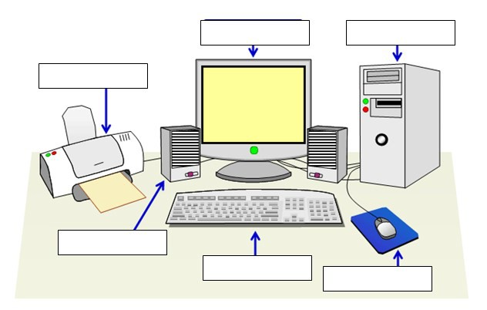

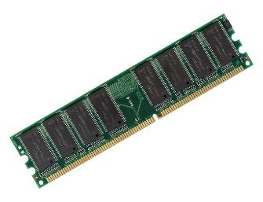
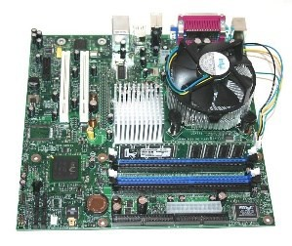

(b) Label these hardware components using these words: Motherboard, RAM, CPU [3]

2
1

3

(c) Select the operating systems from the software listed below.

(A) Windows 10 [ ] (B) Office 2013 [ ] (C) iOS 9 [ ]
(D) Scratch [ ]

6 (a) A computer receives input data which it then processes and outputs. Complete the table below to show, in each case, how the data is input, processed and output:

Input | Processing Instruction | Output
 | Reverse order of letters | retupmoc
31 | Add 7
 | Subtract 15 | 45
3 |  | 12
goodbye |  | GOODBYE
200 | Divide by 2 and add 10

(b) Use the ASCII chart provided.

(i) How does a computer represent the letter w (lower case) as a binary number?

It says:
(ii) What does the binary code shown below say in English?

0100 1000 0100 0101 0100 1100 0100 0101 0100 1110

(iii) Below is a one bit image. Using black to represent 1 and white to represent 0 complete the image.

0 | 1 | 1 | 0 | 0 | 0
1 | 1 | 1 | 0 | 0 | 0
1 | 0 | 1 | 1 | 1 | 1
0 | 0 | 1 | 1 | 1 | 1
0 | 0 | 1 | 0 | 0 | 1
0 | 0 | 0 | 0 | 0 | 0

7 Hansdown Academy has hired a photographer to take photographs of their school. All of the photographs are high resolution (4492 wide x 3328 tall) and have been used to produce framed images that have been displayed around the school. The school now wishes to use some of these photographs on the school website.

(a) Why would it not be a good idea to take the image files as they are and upload them to the school website?

……………………………………………………………………………………………………………………………………

……………………………………………………………………………………………………………………………………

……………………………………………………………………………………………………………………………………

(b) Describe three ways in which these photos could be re-purposed for use on the school website.

1……………………………………………………………………………………………………………………………………………

………………………………………………………………………………………………………………………………………………

2…………………………………………………………………………………………………………………………………………….

………………………………………………………………………………………………………………………………………………

3…………………………………………………………………………………………………………………………………………….

………………………………………………………………………………………………………………………………………………

8 (a) Harry was using the internet to help him with his homework, when an inappropriate website appeared on his screen. What should he do?

………………………………………………………………………………………………………………………………………………

………………………………………………………………………………………………………………………………………………

………………………………………………………………………………………………………………………………………………

………………………………………………………………………………………………………………………………………………

(b) Sonya is 12 years old and has been chatting online to another girl called Sara who is also
12 years old. Sonya asked Sara to have a video chat but Sara keeps making excuses. What should Sonya do and why?

………………………………………………………………………………………………………………………………………………

………………………………………………………………………………………………………………………………………………

………………………………………………………………………………………………………………………………………………

………………………………………………………………………………………………………………………………………………

………………………………………………………………………………………………………………………………………………

………………………………………………………………………………………………………………………………………………

(c) Tanya really enjoys using a micro blogging site called Twitter, but she has noticed that some people using this site can be rude and use the site to bully other people.

Tanya has decided to write a list of rules about how people should behave on this site. Write three rules describing how people should behave below.[3]

1.……………………………………………………………………………………………………………………………………………

……………………………………………………………………………………………………………………………………………….

………………………………………………………………………………………………………………………………………………

2…………………………………………………………………………………………………………………………………………….

………………………………………………………………………………………………………………………………………………

……………………………………………………………………………………………………………………………………………….

3……………………………………………………………………………………………………………………………………………..

……………………………………………………………………………………………………………………………………………….

……………………………………………………………………………………………………………………………………………….

